**PROJECT REPORT TEMPLEATE**

**BUILD AN EVENT MANAGEMENT SYSTEM USING SALESFORCE**

**TEAM ID: NM2023TMID18404**

**1.INRODUCTION**

**1.1 Overview:**

Event management is the process of creating and maintain an event. This process spans from the very beginning of planning all the way to post event strategizing.

**1.2 Purpose:**

At the start, an event manager makes planning decision, such as the time, location, and theme of their event. During an event, event managers observes the events live and make sure things run smoothly. after an event, event managers are tasked with reviewing event data, submitting KPI and ROI findings, and staying on the ball for any post-event offerings.

**2. Problem Definition & Design Thinking**

**2.1 Empathy map**:

An empathy map is a collaborative visualization used to articulate what we know about a particular type of user. It externalizes knowledge about users in order to

1) create a shared understanding of user needs, and

2) aid in decision making

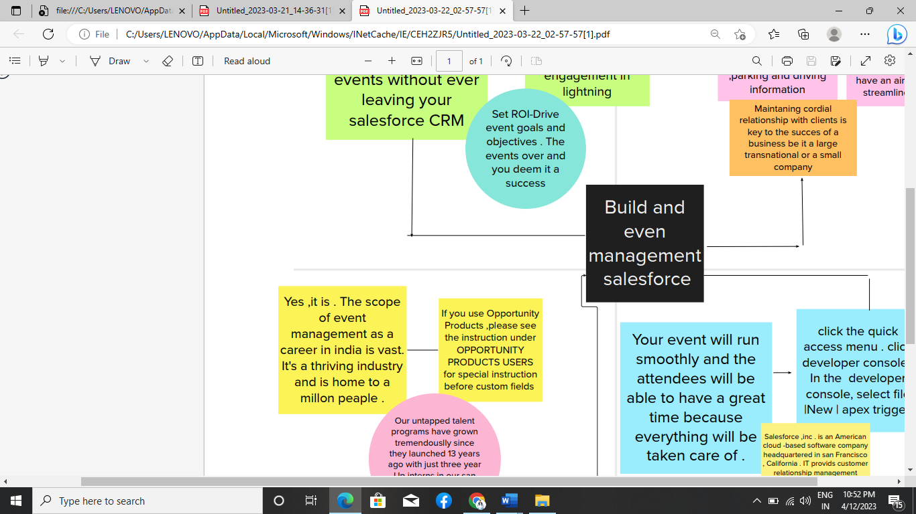

**2.2 Brainstorming:**

Brainstorming is a group problem-solving method that involves the spontaneous contribution of creative ideas and solutions. This technique requires intensive, freewheeling discussion in which every member of the group is encouraged to think aloud and suggest as many ideas as possible based on their diverse knowledge.

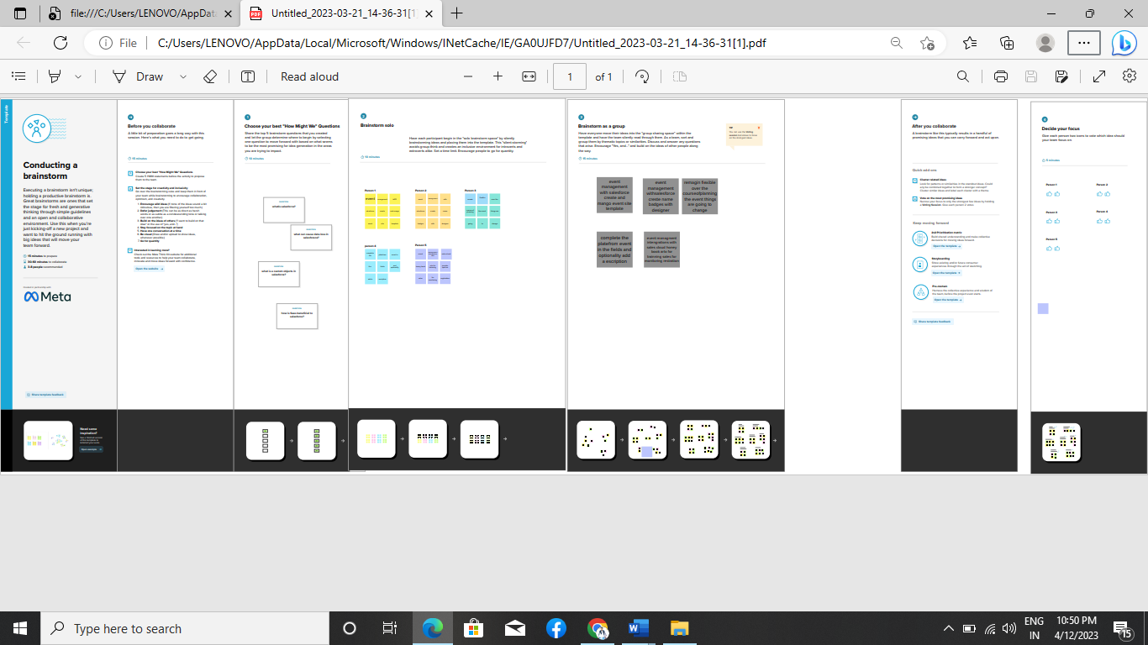

**3. RESULT**

|  |  |  |
| --- | --- | --- |
| **3.1 Data Model:** Object name | Field label | Data type |
| **1.Event** | Event | Text |
| **2.Attendess** | Attendee | Auto number, phone |
| **3.Speakers** | Speaker | Text, Email |
| **4.Vendors** | Vendor | Email, Phone,  Text |

**3.2Activity & Screenshort:**

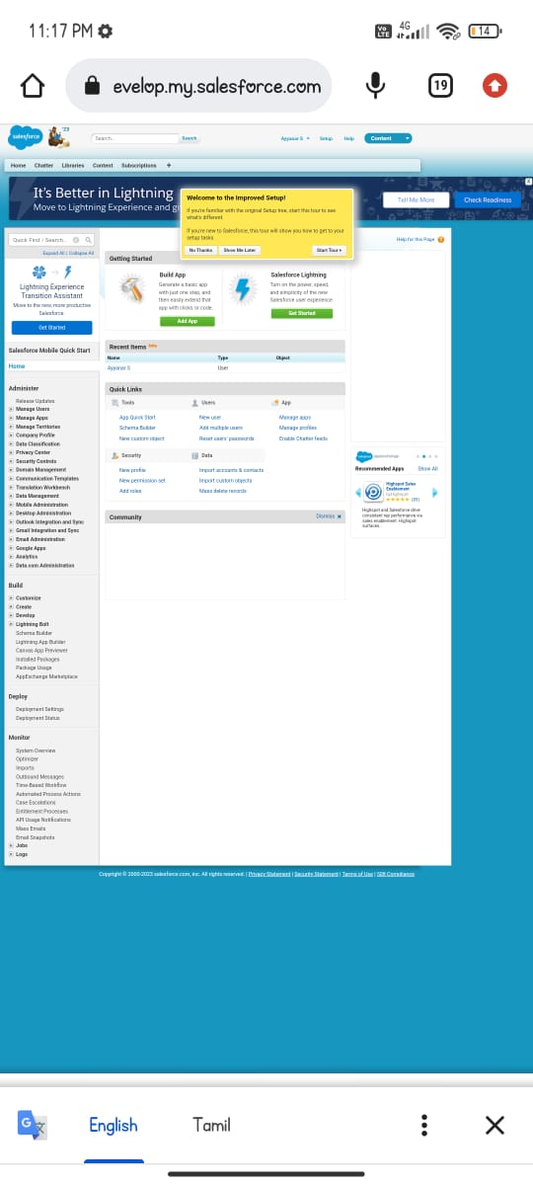

**4. TRAILHEAD PROFILE PUBLIC URL**

**Team Leader – https://trailblazer.me/id/ayyanar321**

**Team Member 1 - https://trailblazer.me/id/atch45**

**Team Member 2 - https://trailblazer.me/id/babyj6**

**Team Member 3 – https://trailblazer.me/id/bhan67**

**5. ADVANTAGES & DISADVANTAGES**

**Advantages:**

**1.opportunities for creativity**

**2.Ability to work different events**

**3.high projection job growth**

**Disadvantages:**

**1.Unconventional work hours**

**2.Time away from family and friends**

**3.Multiple events at the same time**

**6. APPLICATIONS**

**1.vFAIRS is a type of business application that enables companies to store employee information ,manage common EVENT functions ,and execute critical EVENT activities such as processing payroll and administering benefits.**

**2.Features oh vFAIRS application include an employee self-service portal, payroll ,workforce management, recruitment and hiring ,benefits administration ,and talent management .**

**7. CONCLUSION**

**In conclusion ,due many challenges that are facing human resource departments , there is need for organisations to adopt correct and workable policies that will not only ensure they alleviate these challenges but also develop mechanisms of Dellinger with such challenge in case they occur in the future .**

**8. FUTURE SCOPE**

**The project has a very vast scope in future . The project can be implemented on internet in future.**